Git & GitHub
Advanced Assignment
14 Working Examples with Commands, Expected Results & Evidence

Prerequisites
- Git installed and configured: git --version
- GitHub account and authentication configured (SSH or GitHub CLI recommended)
- A test repository; do not experiment with destructive commands in a production repository
- For GitHub exercises, GitHub CLI (gh) is optional but makes fork/PR workflows easier

Initial Repository Setup
mkdir git-advanced-lab
cd git-advanced-lab
git init
git config user.name "Your Name"
git config user.email "your-email@example.com"
echo "# Git Advanced Lab" > README.md
git add README.md
git commit -m "Initial commit"
git branch -M main
# Optional: connect to your GitHub repository
git remote add origin https://github.com/YOUR-USERNAME/git-advanced-lab.git
git push -u origin main
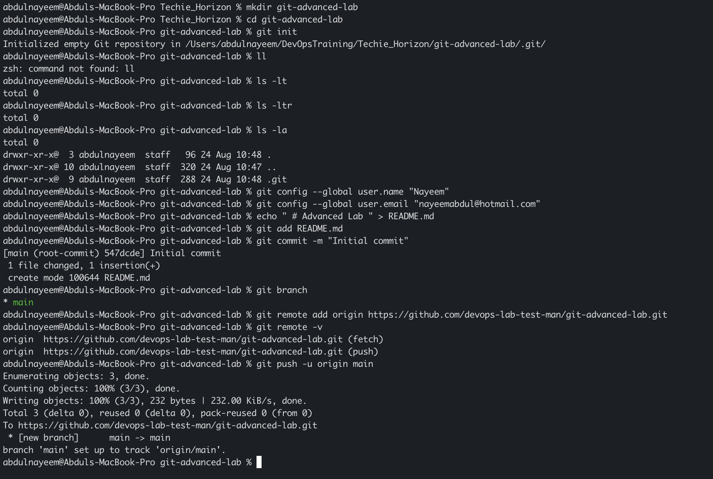
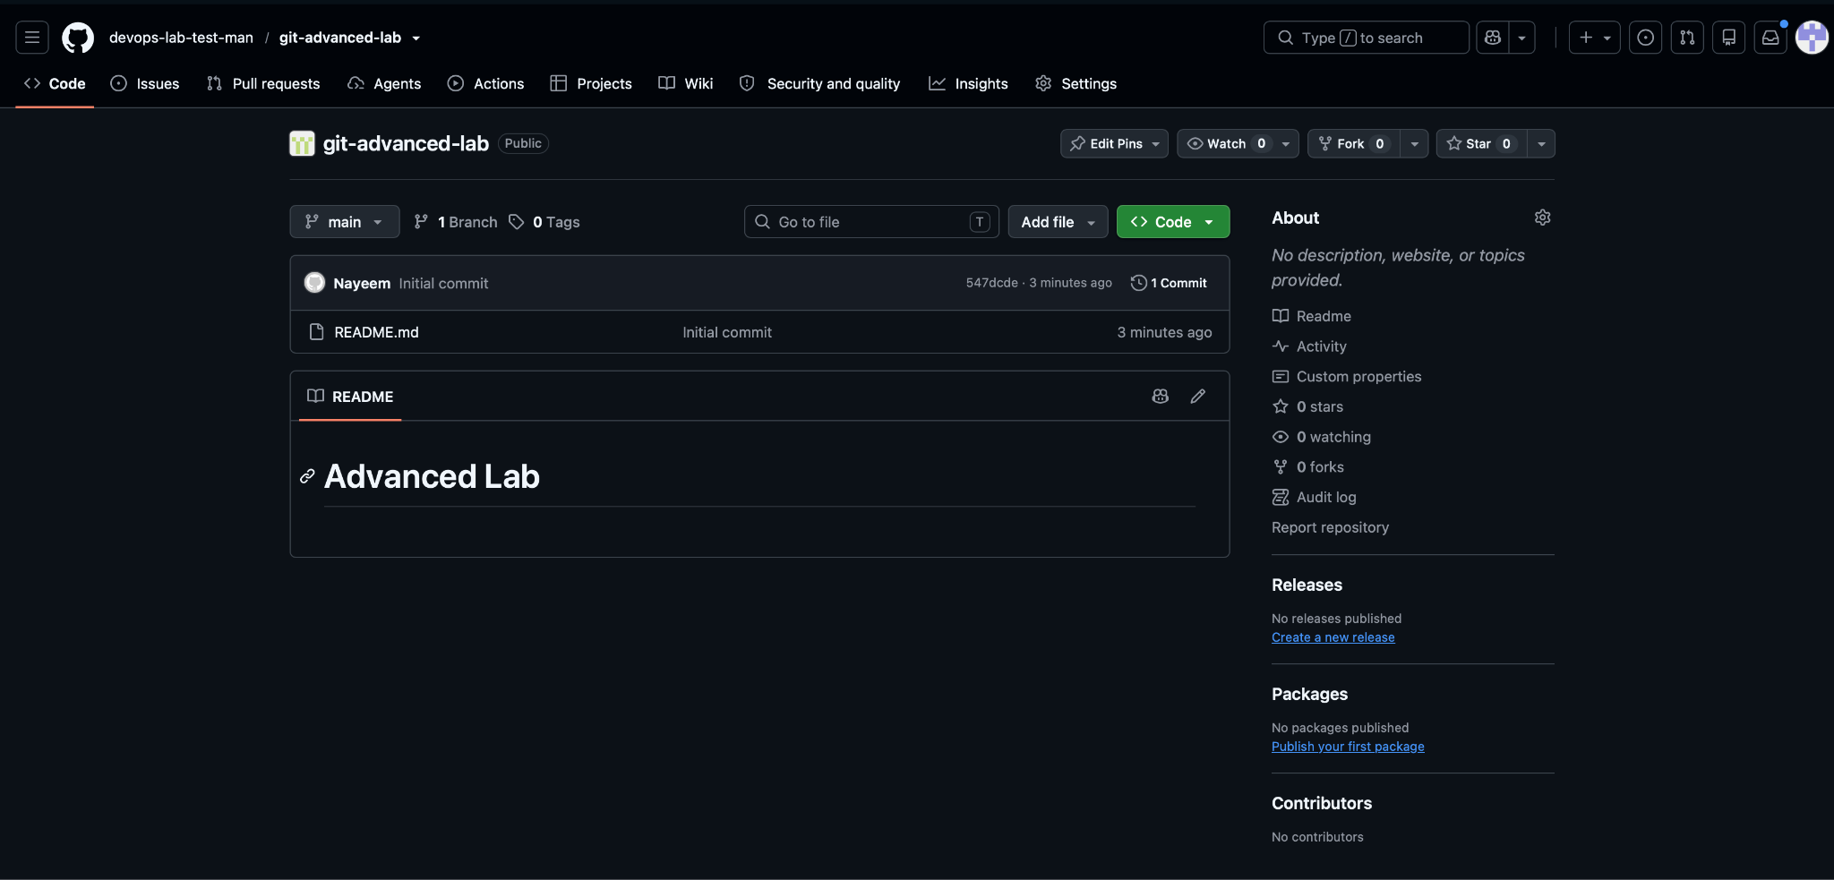

1. Resolve Merge Conflicts
Objective: Create a conflict by having two branches change the same line, resolve it manually, commit the resolution, and push it.

Create the conflict
echo "Environment=Development" > config.txt
git add config.txt
git commit -m "Add environment configuration"
git switch -c feature-a
echo "Environment=Testing" > config.txt
git add config.txt
git commit -m "Update environment for testing"
git switch main
git switch -c feature-b
echo "Environment=Production" > config.txt
git add config.txt
git commit -m "Update environment for production"
git switch main
git merge feature-a
git merge feature-b
# Expected: CONFLICT (content) in config.txt
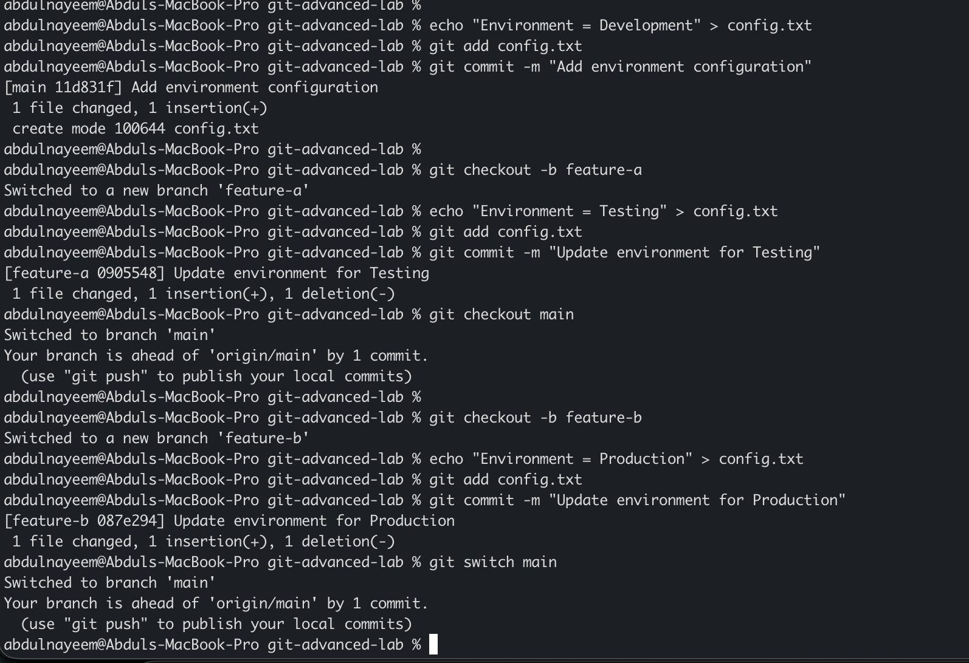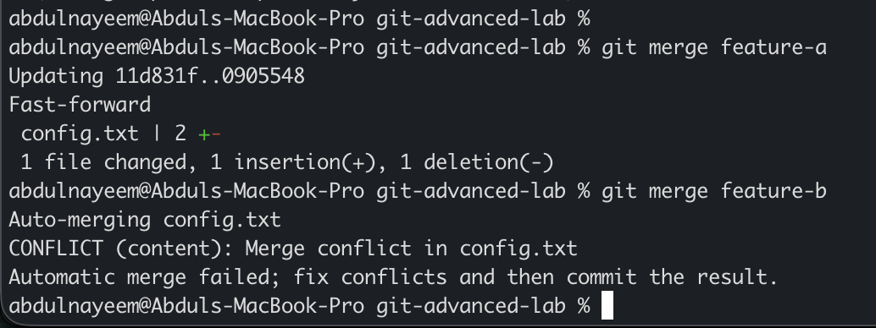

Resolve and push
cat config.txt
# Edit config.txt and choose the required final line, for example:
# Environment=Testing-and-Production
git add config.txt
git commit -m "Resolve configuration merge conflict"
git push origin main
Evidence to capture: Screenshot showing CONFLICT message and conflict markers | Screenshot showing resolved file and git status | git log --oneline --graph output | GitHub main branch showing the merged commit
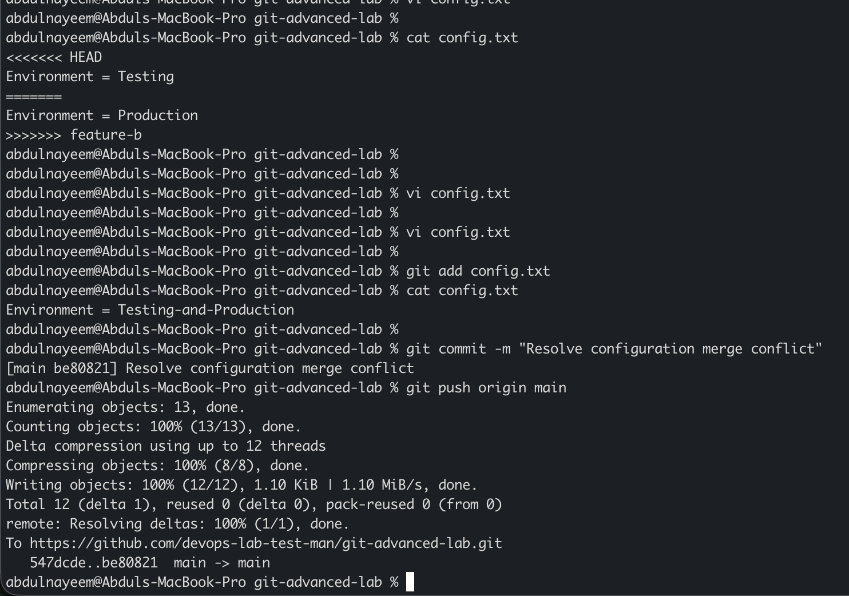

2. Recover Deleted Branch
Objective: Delete a local branch and recover it using reflog.

Create and delete a branch
git switch main
git switch -c recovery-demo
echo "Important work" > recovery.txt
git add recovery.txt
git commit -m "Add important recovery work"
git switch main
git branch -D recovery-demo
git branch

Find the commit and recreate the branch
git reflog --all
# Locate the commit made on recovery-demo.
git branch recovery-demo <COMMIT-ID>
git switch recovery-demo
git log --oneline -3
Evidence to capture: git branch output after deletion | git reflog showing the lost branch commit | Recovered branch and commit in git log
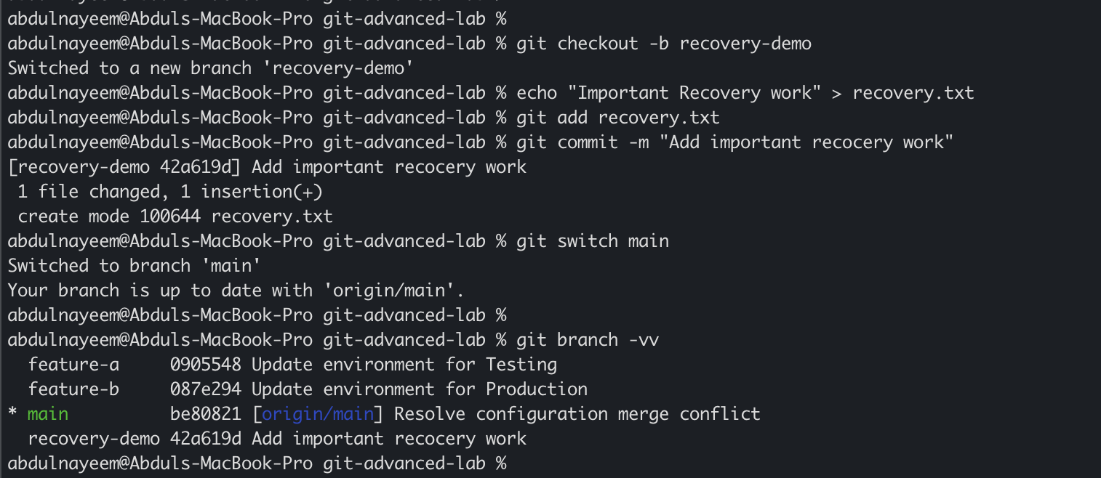
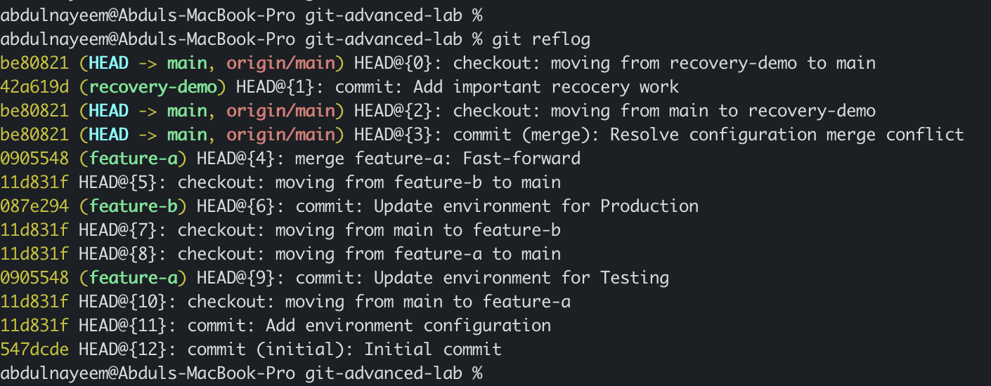
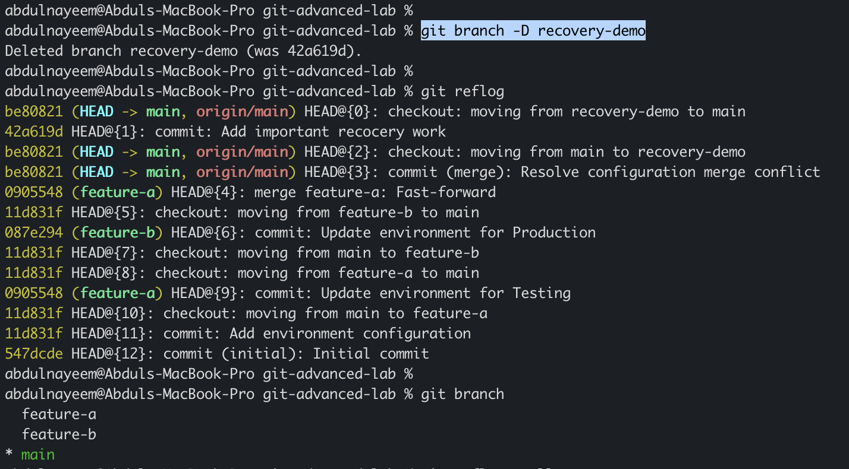
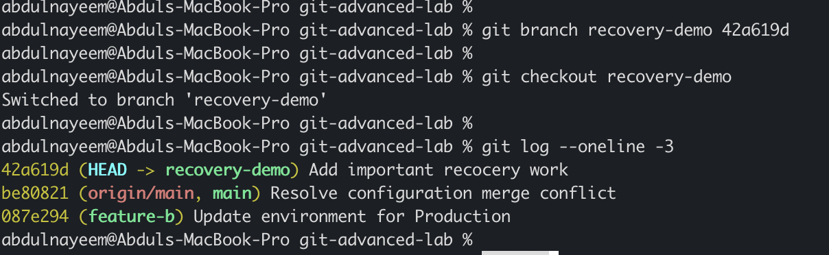

3. Undo Wrong Push
Objective: Push an incorrect commit to GitHub, then undo it with a new commit so history is preserved.

Create and push the wrong change
git switch main
echo "WRONG VALUE" > wrong-change.txt
git add wrong-change.txt
git commit -m "Add wrong configuration"
git push origin main

Undo safely with revert
git revert HEAD
# Save the editor message or use:
# git revert --no-edit HEAD
git push origin main
git log --oneline -4
Evidence to capture: GitHub showing the original wrong commit | Terminal showing the revert commit | GitHub history containing both commits | File content after revert
Note: git revert is preferred for shared branches because it preserves existing history. Do not use git push --force to erase a shared commit unless your instructor explicitly asks for that scenario.
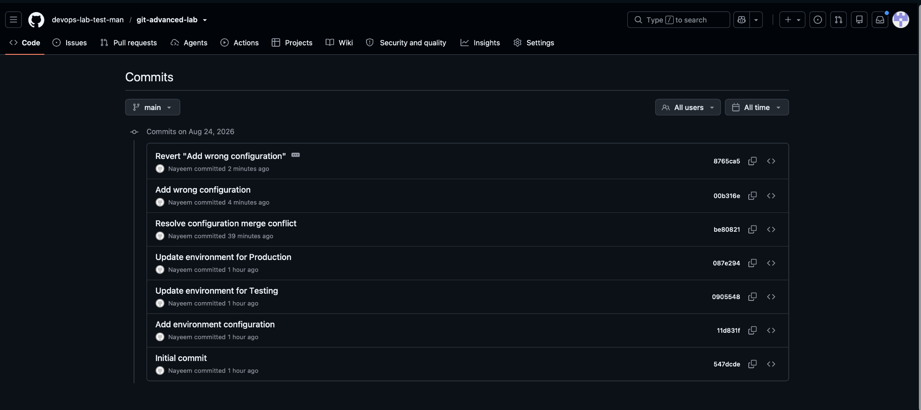
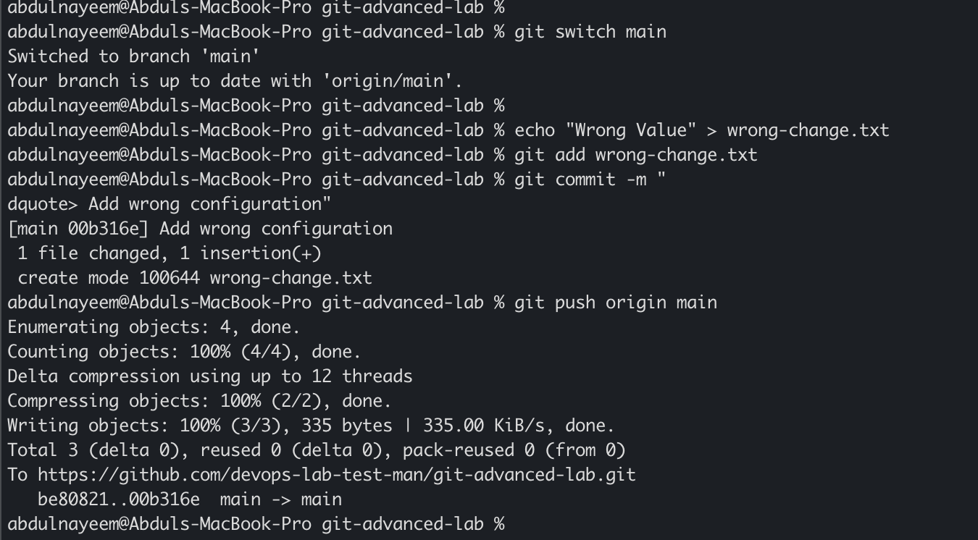
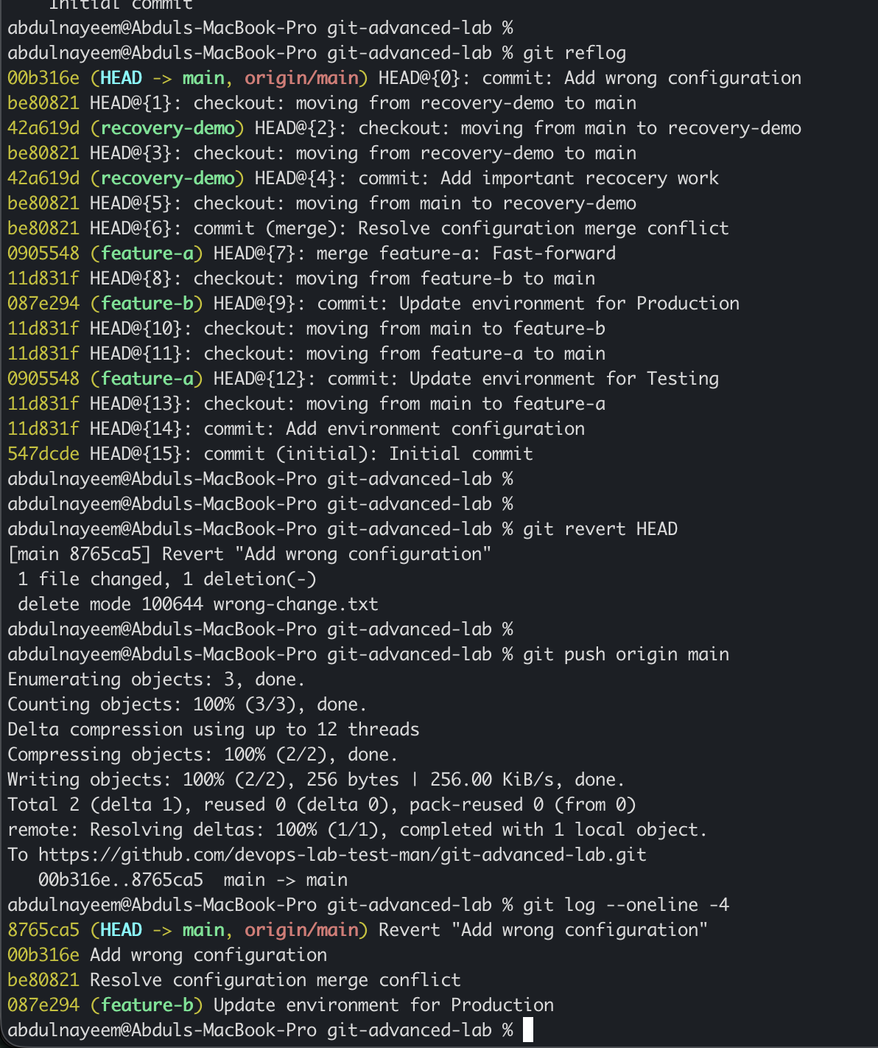

4. Amend a Commit
Objective: Add a missing file to the most recent commit using git commit --amend.

Create the initial commit
echo "Application configuration" > app.conf
git add app.conf
git commit -m "Add application configuration"
echo "Database configuration" > db.conf
git status

Amend the commit
git add db.conf
git commit --amend --no-edit
git show --stat HEAD
git log --oneline -2
Evidence to capture: git status before amend | git show --stat HEAD showing both files | Final commit message and hash
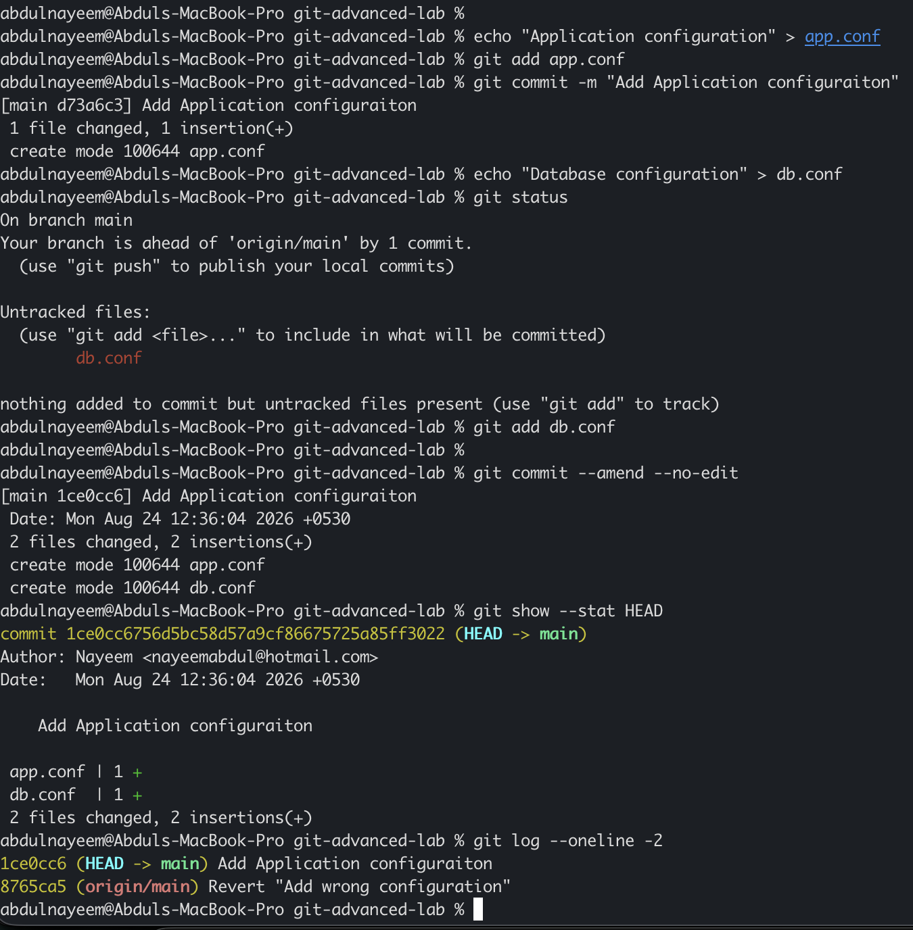

5. Cherry-pick a Commit
Objective: Apply one specific commit from another branch without merging the entire branch.

Create the source commit
git switch -c feature-cherry
echo "Feature A" > feature-a.txt
git add feature-a.txt
git commit -m "Add Feature A"
git log --oneline -2

Cherry-pick into main
# Copy the commit hash from the previous command
git switch main
git cherry-pick <COMMIT-ID>
git log --oneline -3
git push origin main
Evidence to capture: Source branch commit hash | main branch log after cherry-pick | git show showing the copied change
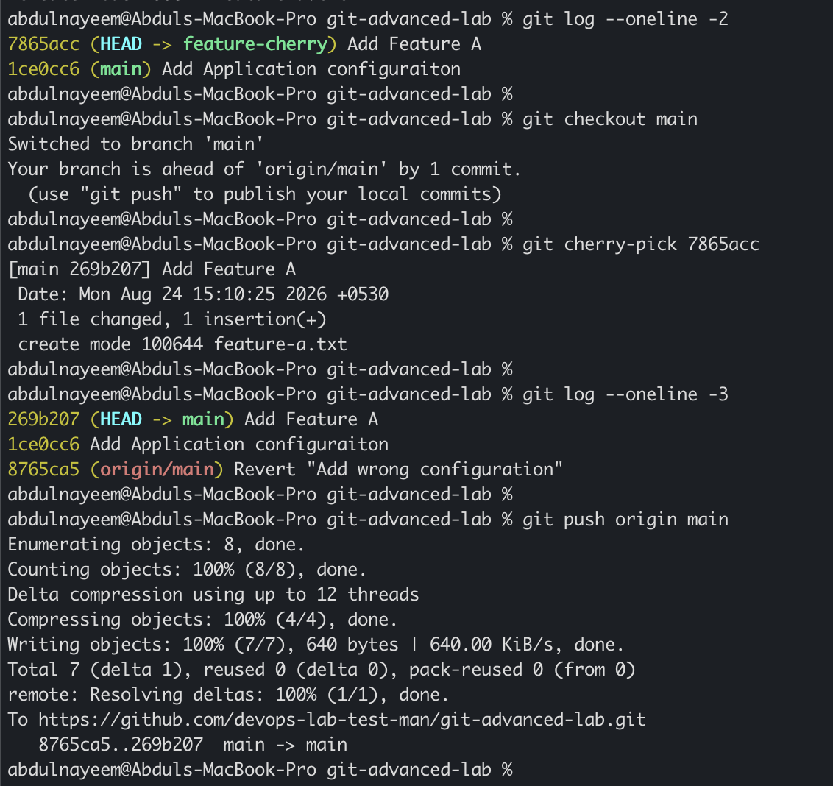

6. Interactive Rebase
Objective: Reorder and squash several local commits into one clean commit.

Create three commits
git switch -c rebase-demo
echo "Line 1" > rebase.txt
git add rebase.txt
git commit -m "Add first line"
echo "Line 2" >> rebase.txt
git add rebase.txt
git commit -m "Add second line"
echo "Line 3" >> rebase.txt
git add rebase.txt
git commit -m "Add third line"
git log --oneline -4

Squash and reorder
git rebase -i HEAD~3
# In the editor, change for example:
# pick <hash1> Add first line
# squash <hash2> Add second line
# squash <hash3> Add third line
# Save and enter a final clean message such as:
# Add complete rebase demonstration
git log --oneline -4
git status
Evidence to capture: Before-rebase git log | Interactive rebase editor showing pick/squash | After-rebase clean history | Final file content
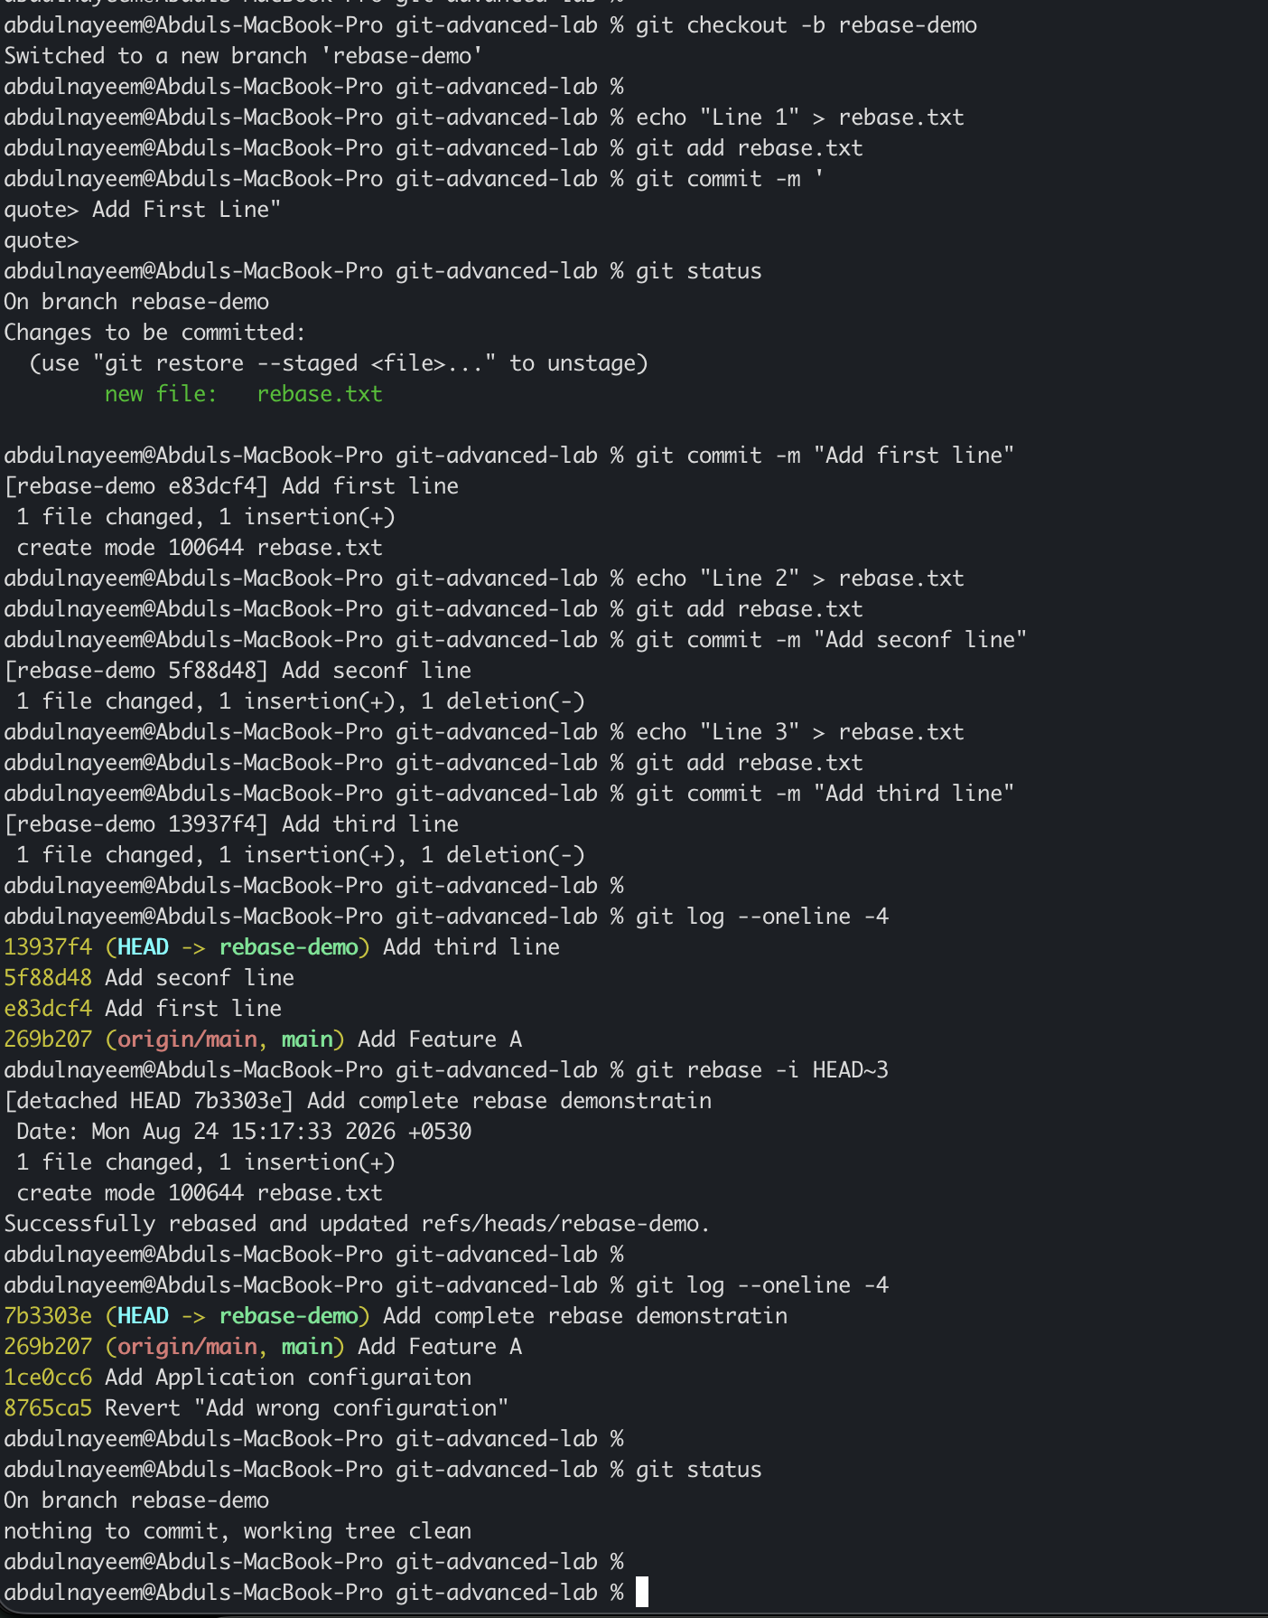

7. Tagging & Release
Objective: Create v1.0, push it, delete it locally/remotely, and restore it.

Create and push the tag
git switch main
git tag -a v1.0 -m "Release version 1.0"
git tag
git show v1.0
git push origin v1.0

Delete and restore the tag
git tag -d v1.0
git push origin --delete v1.0
# Restore the same tag on the intended release commit:
git tag -a v1.0 <RELEASE-COMMIT> -m "Restore release version 1.0"
git push origin v1.0
git ls-remote --tags origin
Evidence to capture: git show v1.0 before deletion | GitHub Tags/Releases page | Output confirming tag deletion | git ls-remote --tags origin showing restored v1.0
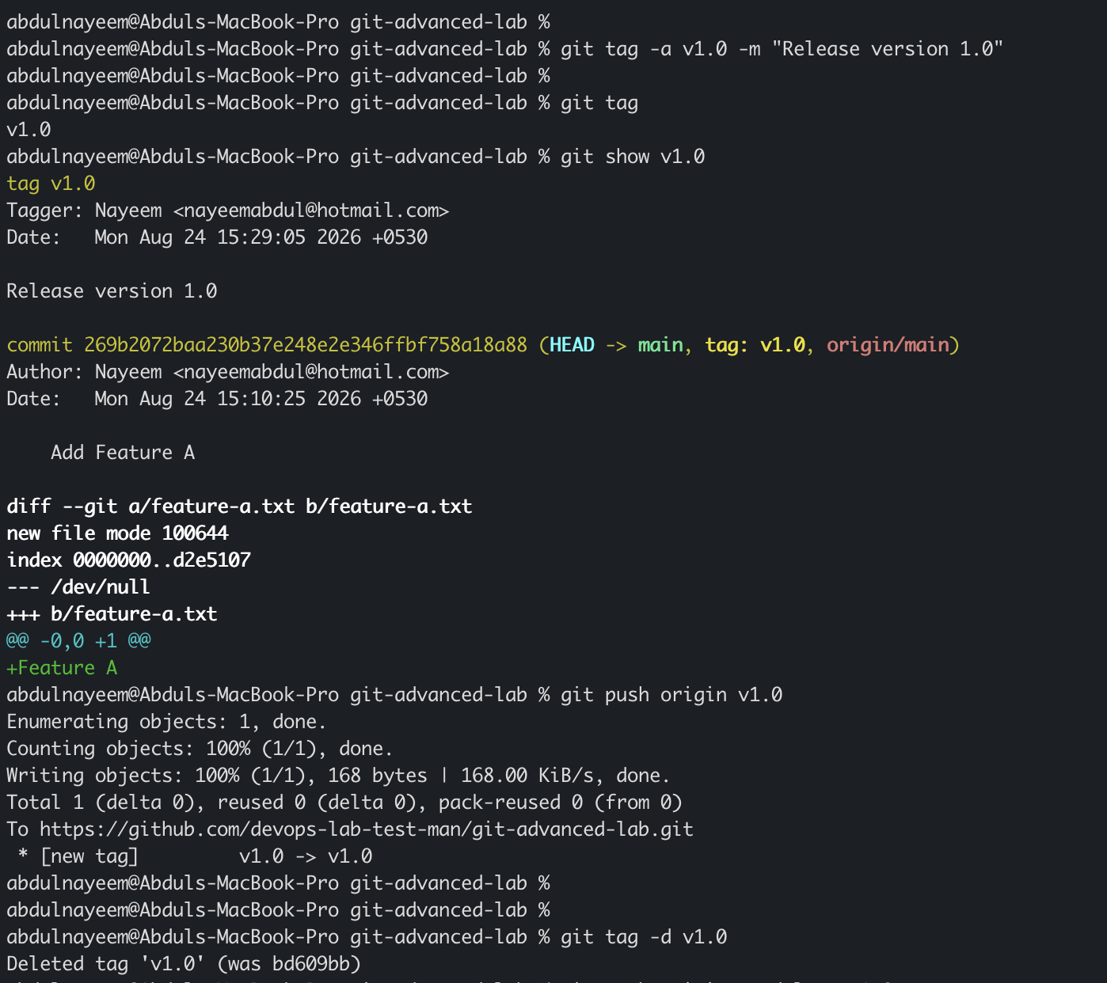
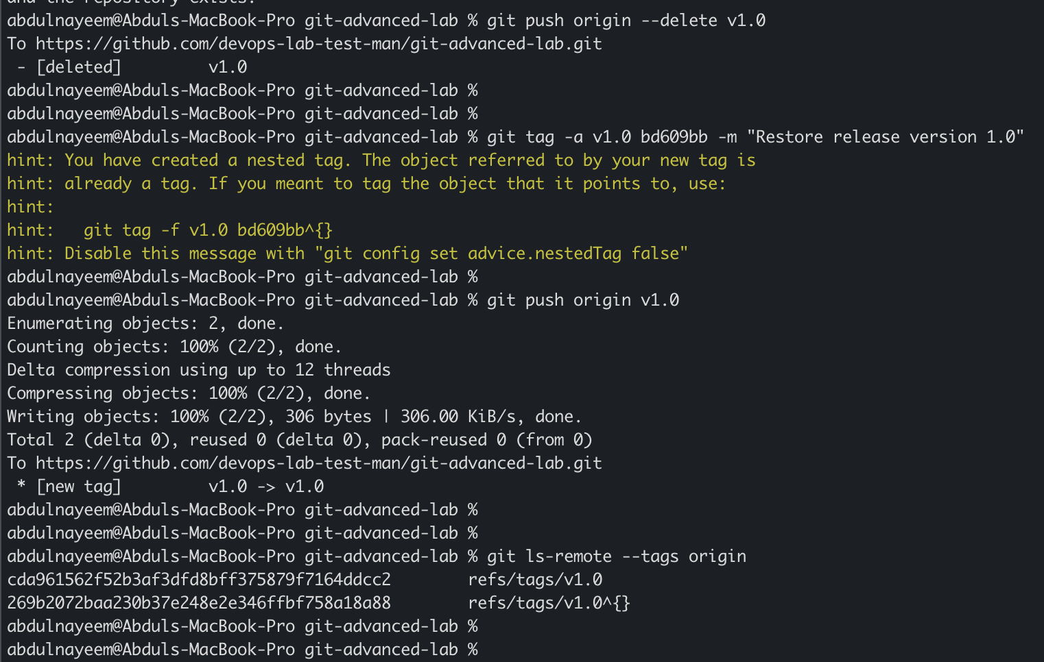

8. Clone with Sparse Checkout
Objective: Clone repository metadata and working files for only a selected subdirectory.

Create a repository with multiple directories
# In a source repository:
mkdir -p app docs scripts
echo "application" > app/app.txt
echo "documentation" > docs/readme.txt
echo "script" > scripts/build.sh
git add .
git commit -m "Add multiple project directories"
git push origin main

Sparse clone
cd ..
git clone --filter=blob:none --no-checkout https://github.com/YOUR-USERNAME/git-advanced-lab.git sparse-lab
cd sparse-lab
git sparse-checkout init --cone
git sparse-checkout set app
git checkout main
find . -maxdepth 2 -type f | sort
Evidence to capture: Repository directory listing before sparse checkout | Sparse-checkout commands | Final listing showing selected app/ directory and repository metadata
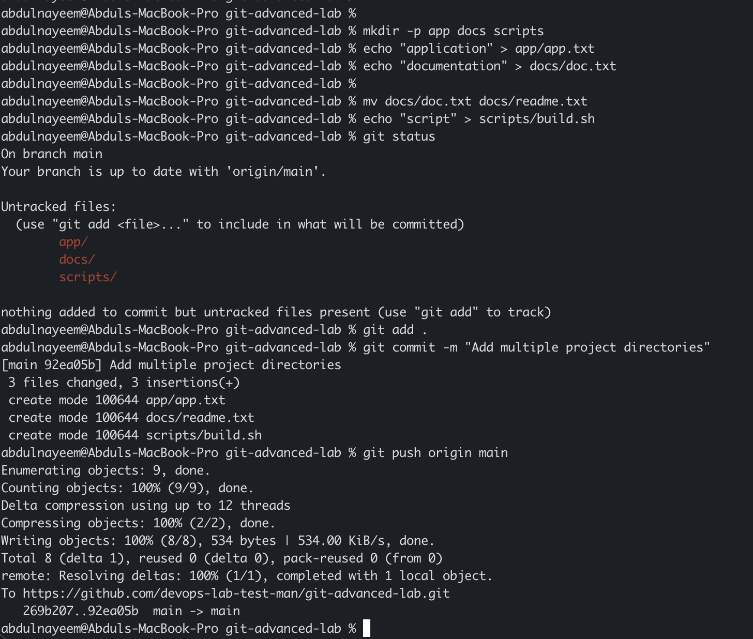
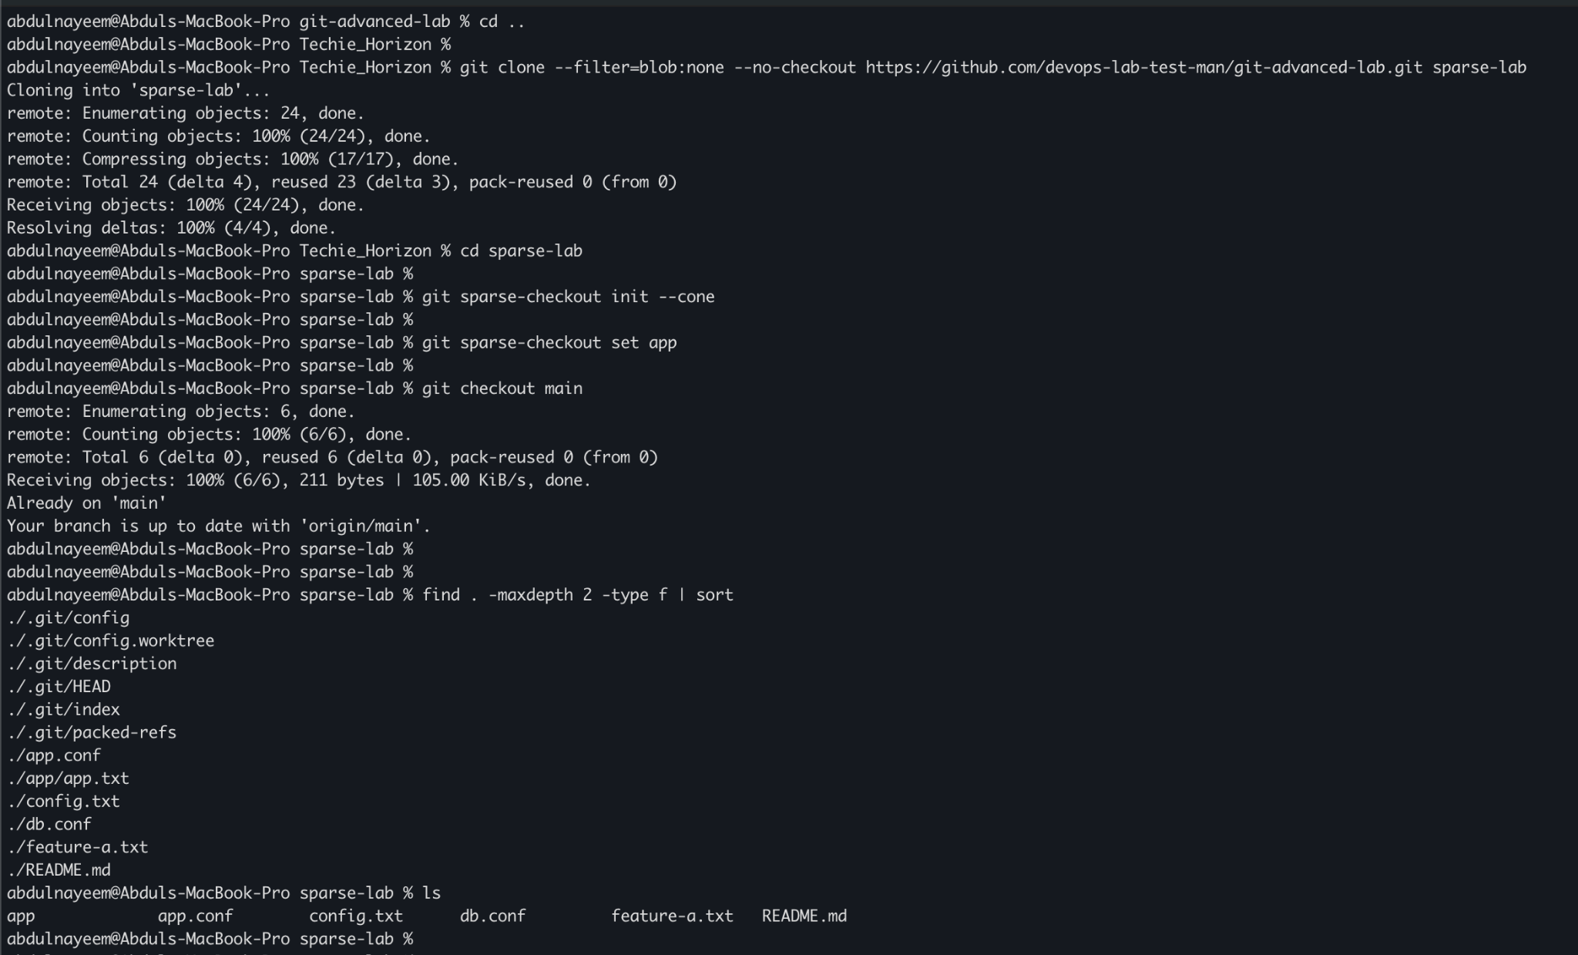

9. Reset vs Revert Challenge
Objective: Demonstrate the difference between reset --hard and revert.

Create a bad commit
git switch -c reset-revert-demo
echo "Good" > reset-revert.txt
git add reset-revert.txt
git commit -m "Add good content"
echo "Bad" >> reset-revert.txt
git add reset-revert.txt
git commit -m "Add bad content"
git log --oneline -3

Demonstrate reset --hard
# Record the bad commit hash first.
git reset --hard HEAD~1
git log --oneline -3
cat reset-revert.txt
# The branch pointer moved backward and the bad commit is no longer on the branch.
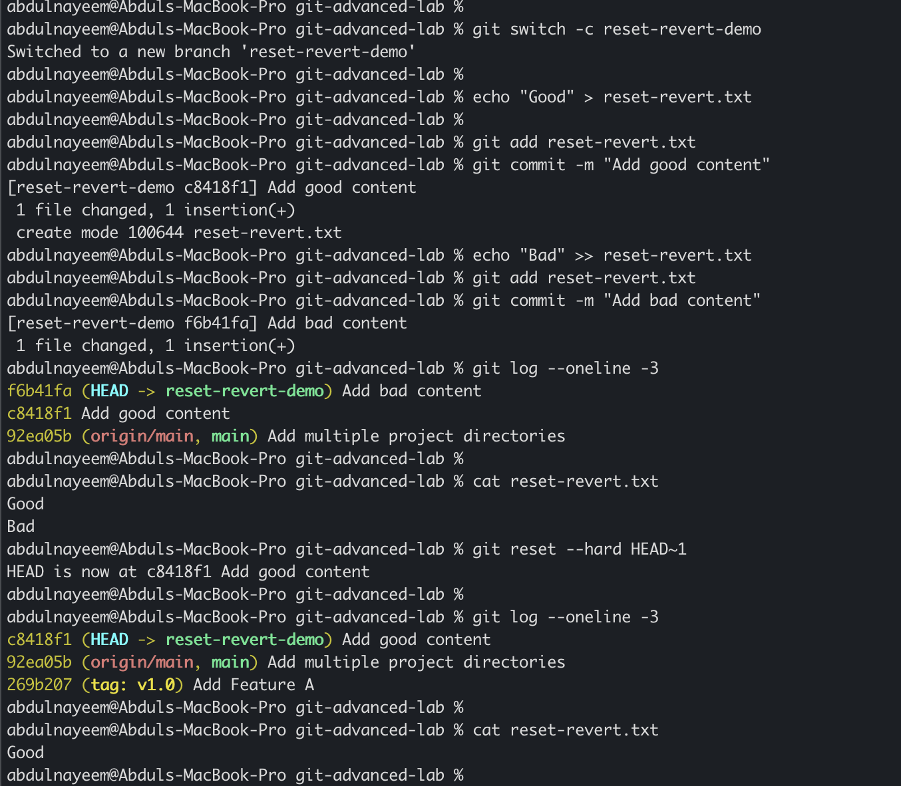

Demonstrate revert separately
git reflog
# Recreate a branch at the bad commit if needed:
git switch -c revert-demo <BAD-COMMIT-ID>
git revert <BAD-COMMIT-ID>
git log --oneline -4
cat reset-revert.txt
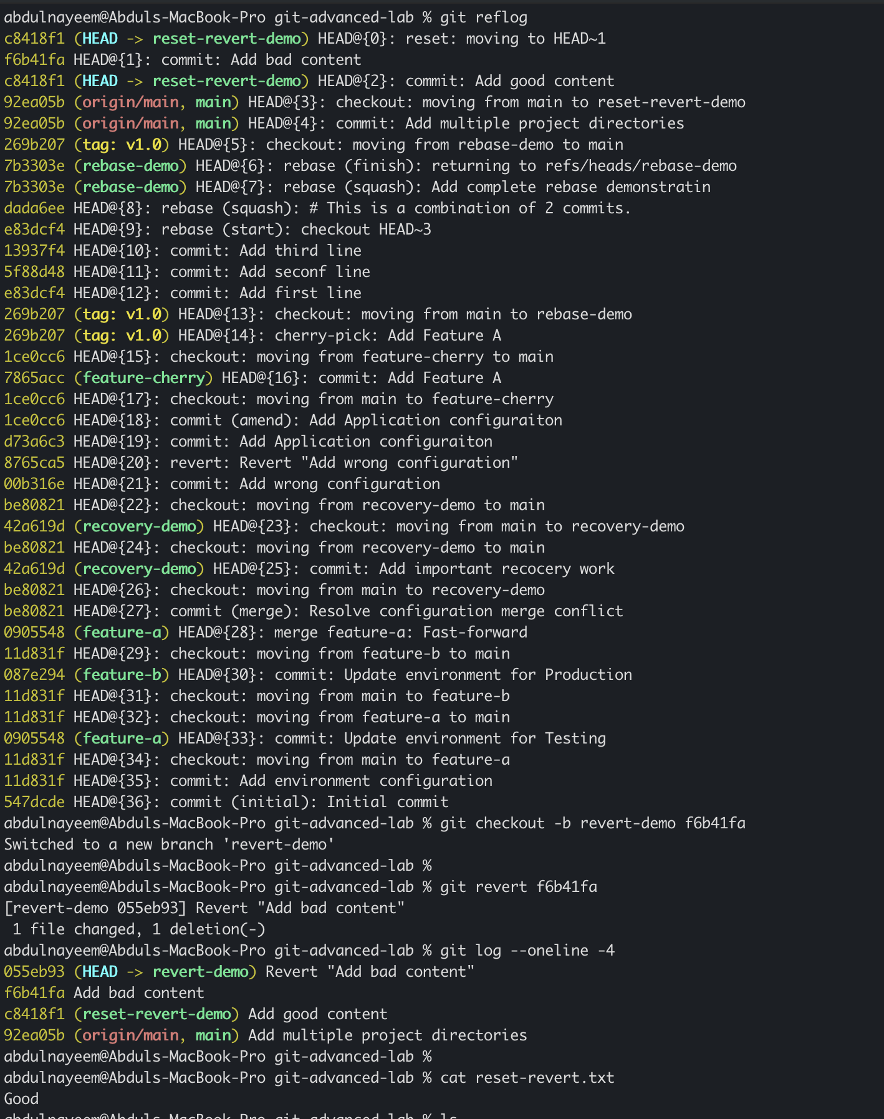
Evidence to capture: Log before reset | Log/file after reset --hard | Reflog showing previous position | Log after revert showing a new inverse commit
Note: reset --hard changes branch history and discards working-tree changes. revert creates a new commit that reverses an earlier commit and is safer for shared history.

10. Detached HEAD Challenge
Objective: Checkout a specific commit, observe detached HEAD, and create a branch from that point.

Enter detached HEAD
git log --oneline --all -5
git checkout <COMMIT-ID>
git status
# Expected: HEAD detached at <COMMIT-ID>

Create a branch from detached HEAD
git switch -c detached-recovery
echo "Work from historical point" > historical-work.txt
git add historical-work.txt
git commit -m "Continue work from historical commit"
git log --oneline -3
git status
Evidence to capture: git status showing detached HEAD | Branch creation command | Final branch log showing the new commit
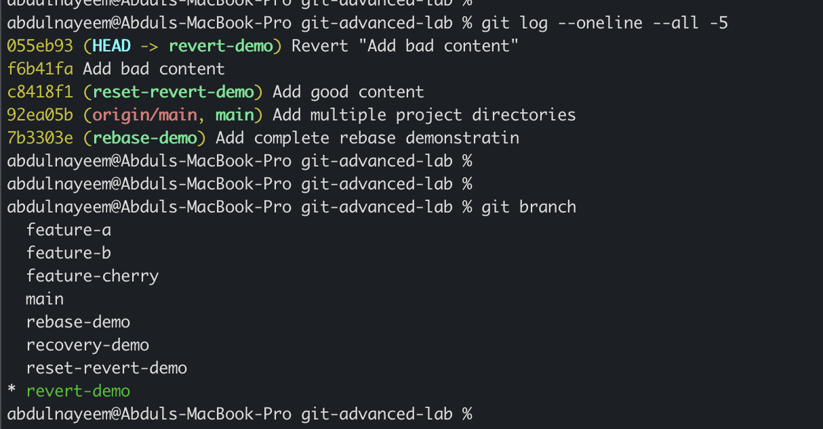
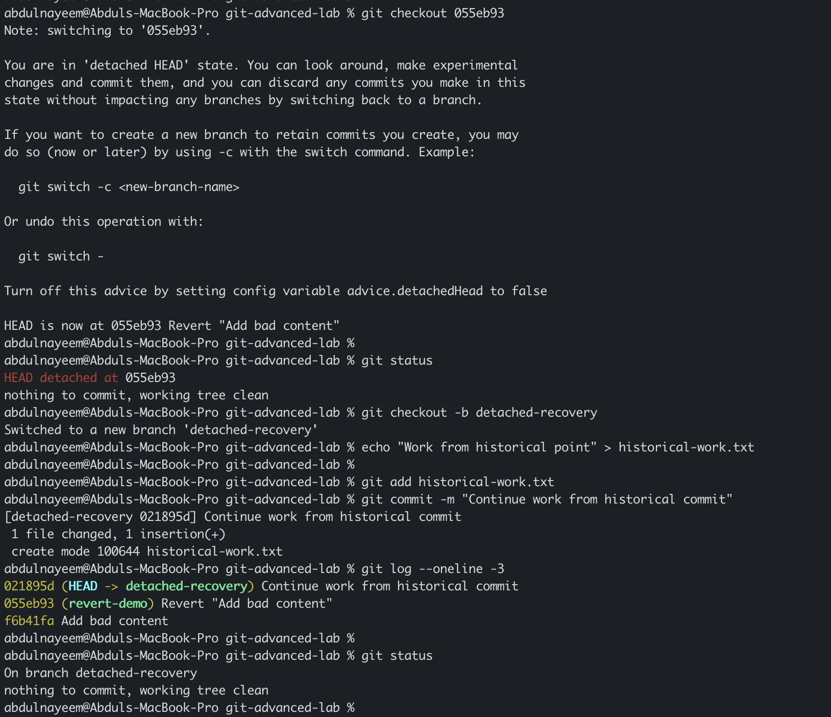

11. Git Hooks Challenge
Objective: Configure a pre-commit hook that rejects commit messages unless they start with JIRA- followed by three digits.

Create the hook
mkdir -p .git/hooks
cat > .git/hooks/commit-msg <<'EOF'
#!/bin/sh
commit_msg=$(head -n 1 "$1")
case "$commit_msg" in
JIRA-[0-9][0-9][0-9]*)
exit 0
;;
*)
echo "ERROR: Commit message must start with JIRA-XXX"
echo "Example: JIRA-123 Fix login issue"
exit 1
;;
esac
EOF
chmod +x .git/hooks/commit-msg
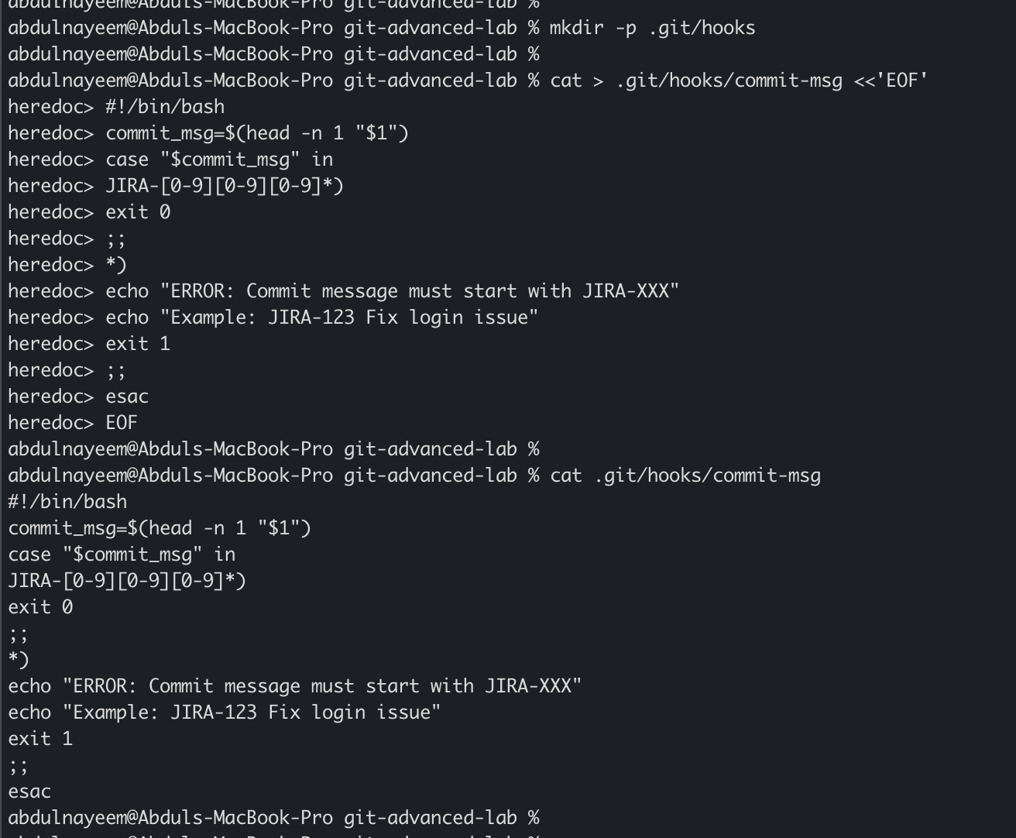

Test rejection and acceptance
echo "hook test" > hook-test.txt
git add hook-test.txt
git commit -m "Fix hook test"
# Expected: commit rejected
git commit -m "JIRA-123 Fix hook test"
# Expected: commit succeeds
git log -1 --oneline
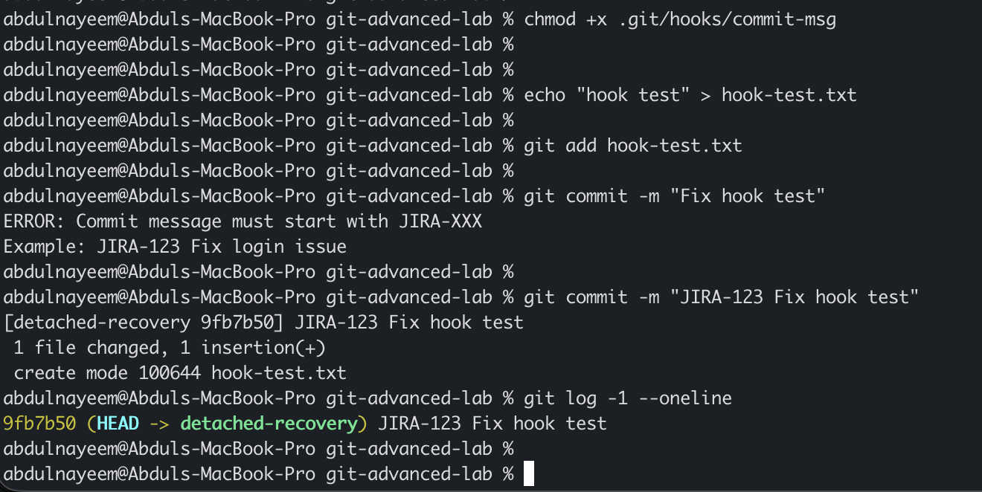
Evidence to capture: Hook file content | Rejected commit terminal output | Successful JIRA-123 commit | git log showing compliant message
Note: The hook above is a commit-msg hook because it validates the commit message file. Hooks stored only in .git/hooks are local to the clone; teams commonly distribute hooks through a shared script/tooling mechanism.

12. Squash Merge vs Rebase Merge
Objective: Compare squash merging, which creates one new combined commit, with rebase merging, which replays commits and preserves individual commit changes.

Prepare feature commits
git switch main
git switch -c feature-compare
echo "Feature line 1" > compare.txt
git add compare.txt
git commit -m "Feature: add line 1"
echo "Feature line 2" >> compare.txt
git add compare.txt
git commit -m "Feature: add line 2"
git push -u origin feature-compare
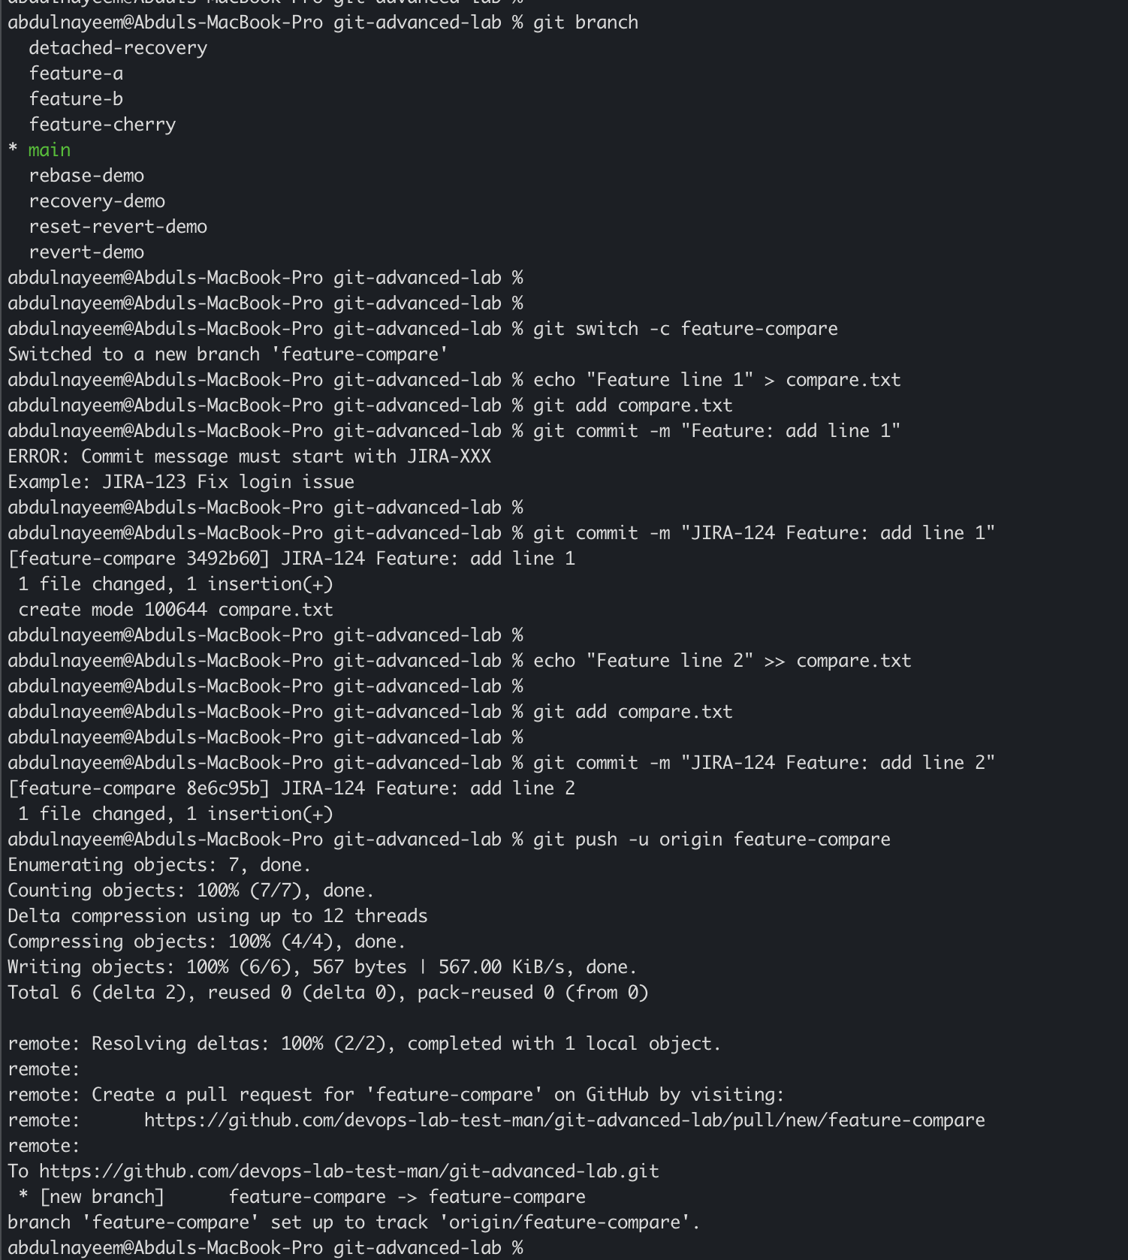

Squash-merge demonstration
git switch main
git merge --squash feature-compare
git commit -m "Feature: complete comparison"
git log --oneline --graph --decorate -8
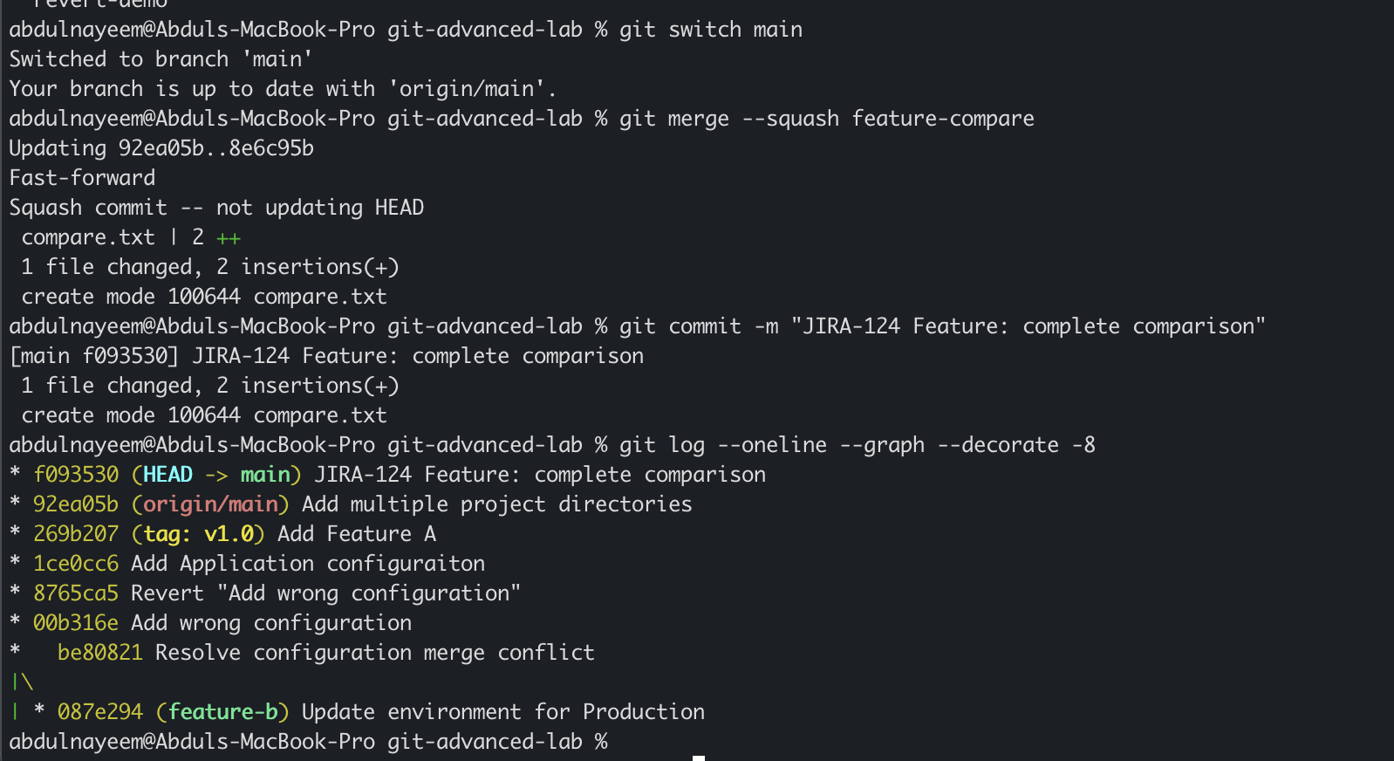

Rebase-merge demonstration
# Reset the lab or use a fresh branch/repository for a clean comparison.
git switch main
git switch -c feature-rebase
echo "Rebase line 1" > rebase-compare.txt
git add rebase-compare.txt
git commit -m "Rebase feature: line 1"
echo "Rebase line 2" >> rebase-compare.txt
git add rebase-compare.txt
git commit -m "Rebase feature: line 2"
git rebase main
git switch main
git merge --ff-only feature-rebase
git log --oneline --graph --decorate -10
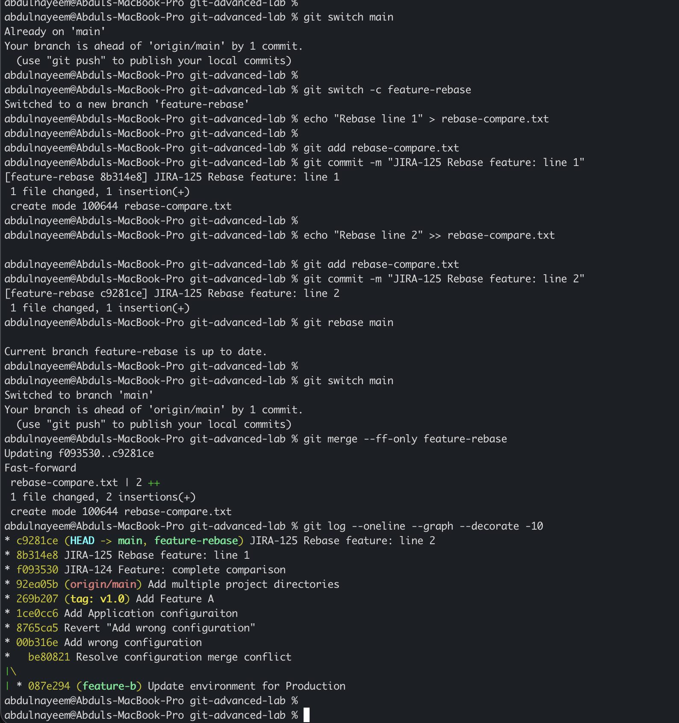
Evidence to capture: Squash merge log graph | Rebase/fast-forward merge log graph | GitHub pull request history if using the UI | Side-by-side screenshots of the two histories
Note: A squash merge combines feature commits into one new commit. A rebase followed by fast-forward preserves the rebased individual commits but gives them new commit IDs. Use separate branches/repositories for a clean classroom comparison.

13. Fork & Pull Request Workflow
Objective: Fork a repository, clone the fork, make a change, push a branch, and submit a pull request to the original repository.

Fork and clone
# On GitHub: open the instructor/public repository and click Fork.
# Then clone YOUR fork:
git clone https://github.com/YOUR-USERNAME/FORKED-REPO.git
cd FORKED-REPO
git remote -v
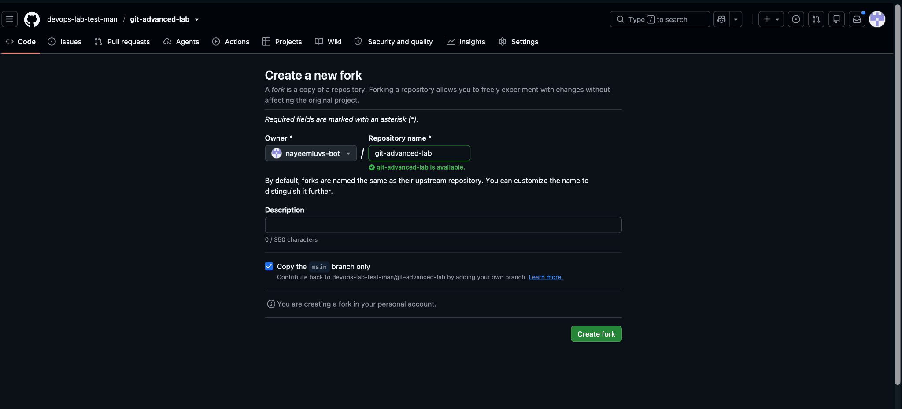
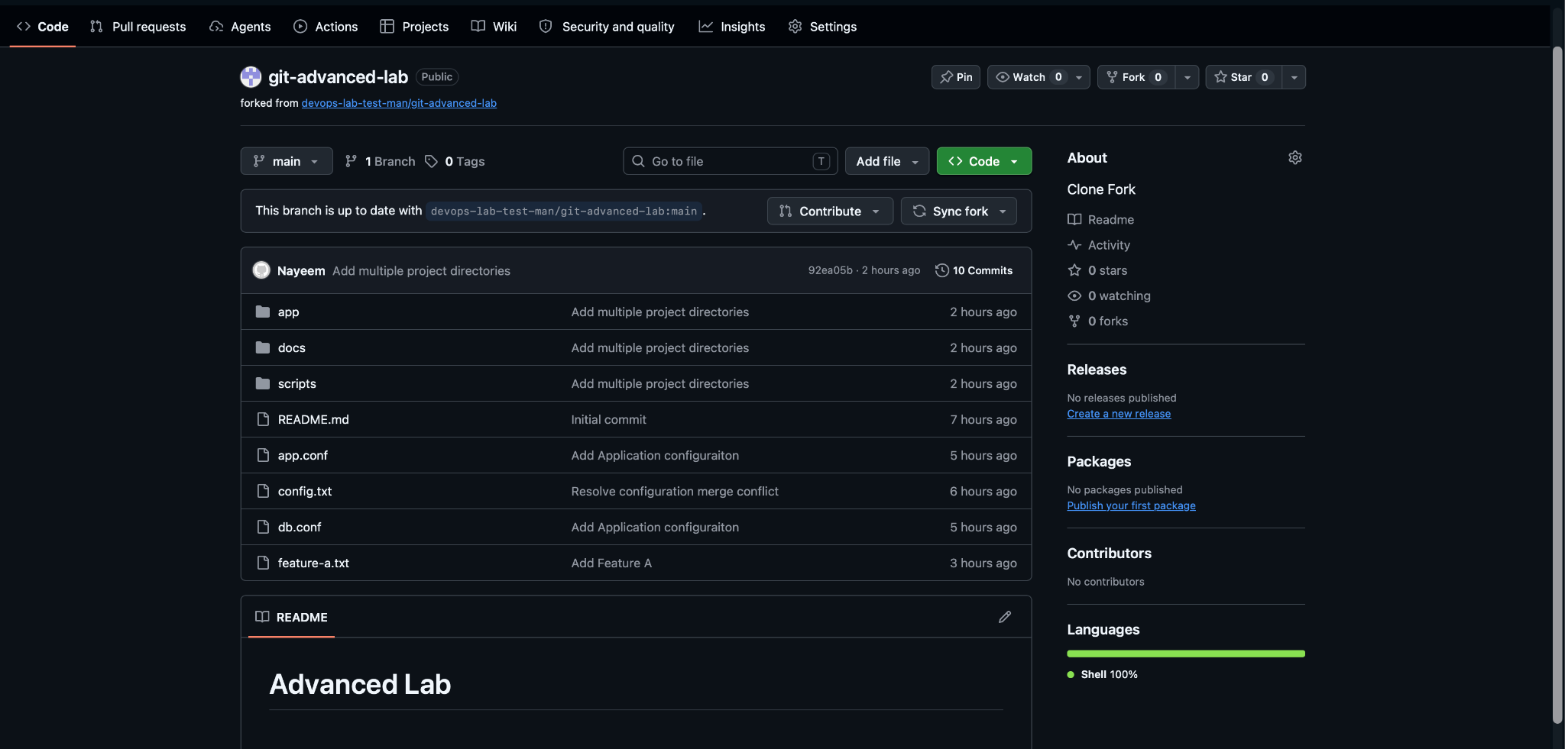
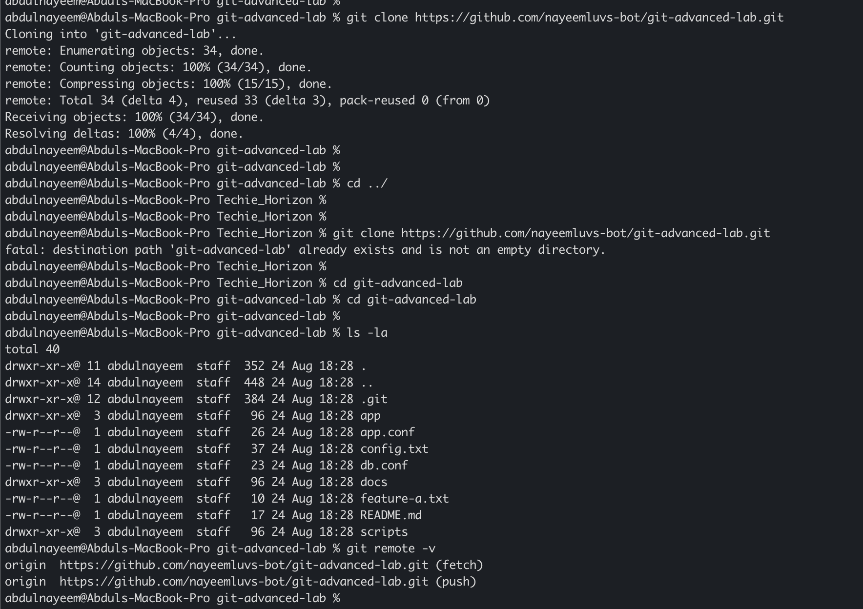

Create a change and push
git switch -c docs-update
echo "Student contribution" >> README.md
git add README.md
git commit -m "JIRA-133 Improve documentation"
git push -u origin docs-update
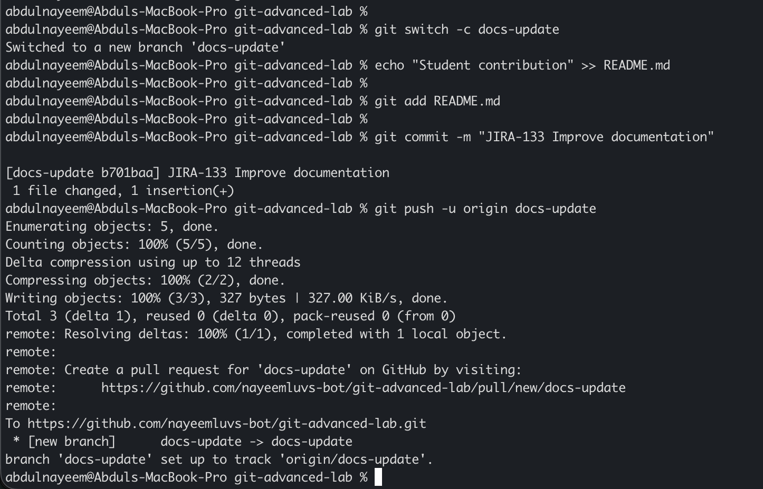

Create the pull request
# GitHub CLI option:
gh pr create --base main --head YOUR-USERNAME:docs-update --title "Improve documentation" --body "Adds a small documentation improvement."
# Or open your fork on GitHub and use "Compare & pull request",
# select the original repository as the base repository, then submit the PR.
Evidence to capture: Fork page showing the fork | Local remotes output | Feature branch on GitHub | Submitted pull request page with base/head repositories
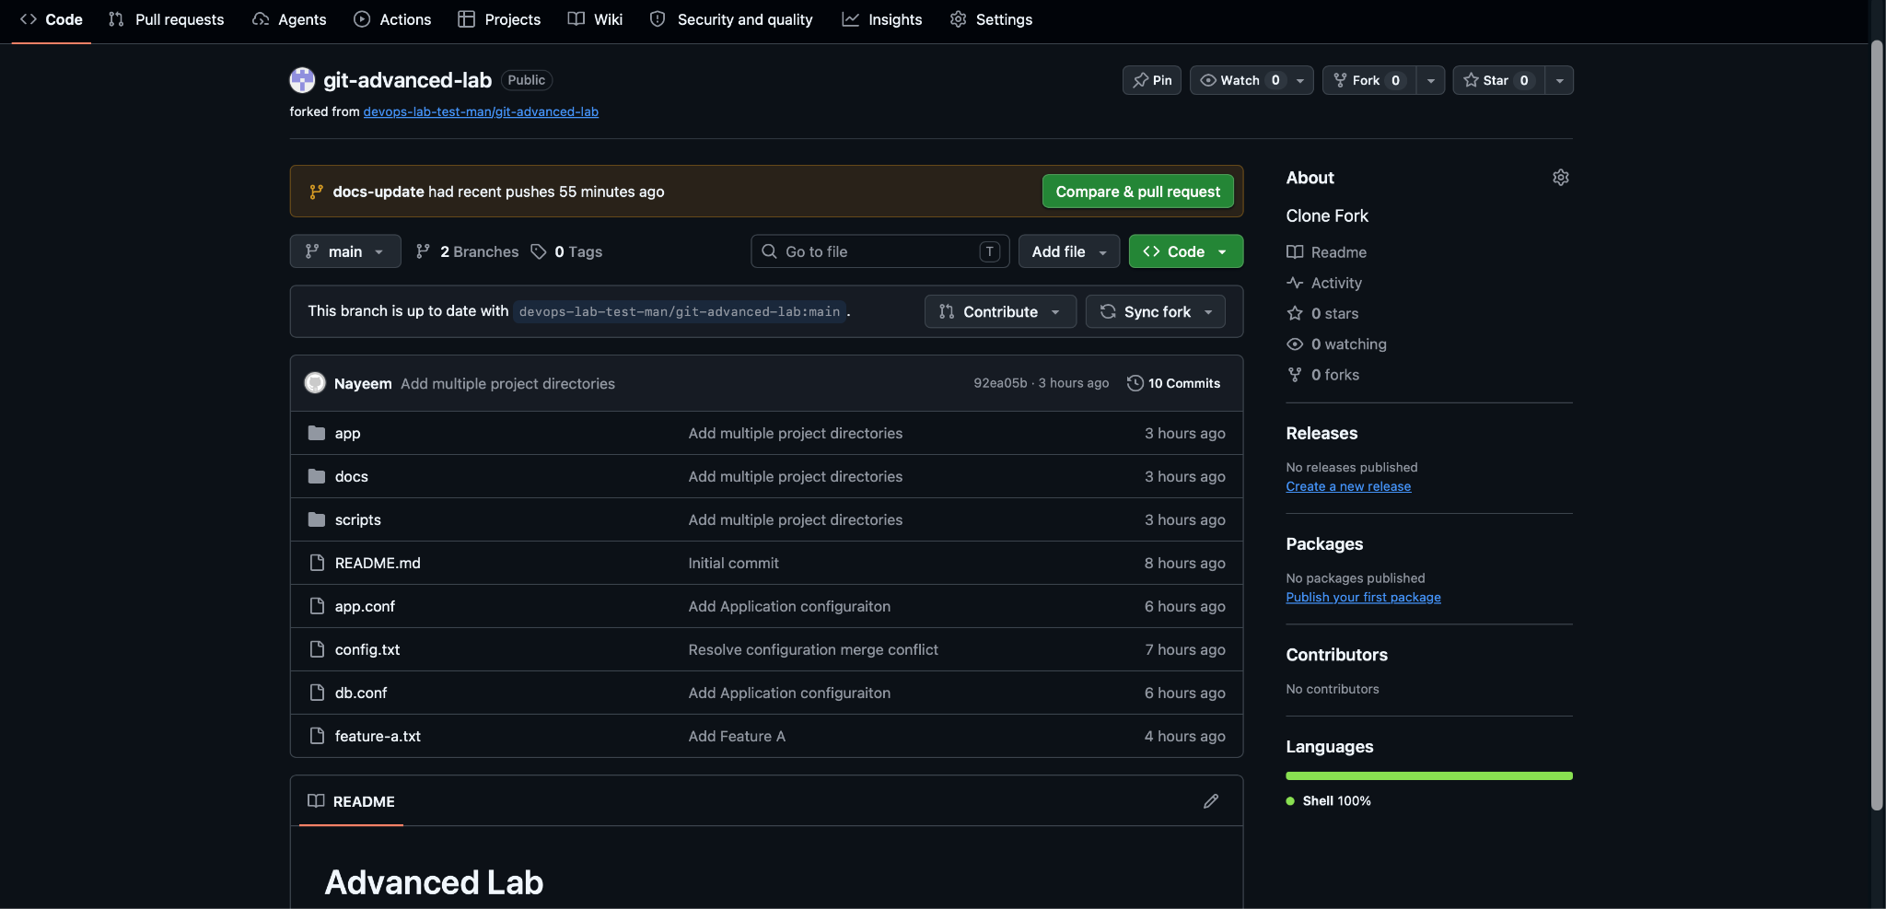

14. Recover Lost Commit
Objective: Create a commit, reset hard to remove it from the branch, then recover the commit using reflog.

Create and lose the commit
git switch -c lost-commit-demo
echo "Recover me" > lost.txt
git add lost.txt
git commit -m "Add recoverable work"
git log --oneline -2
git reset --hard HEAD~1
git log --oneline -2
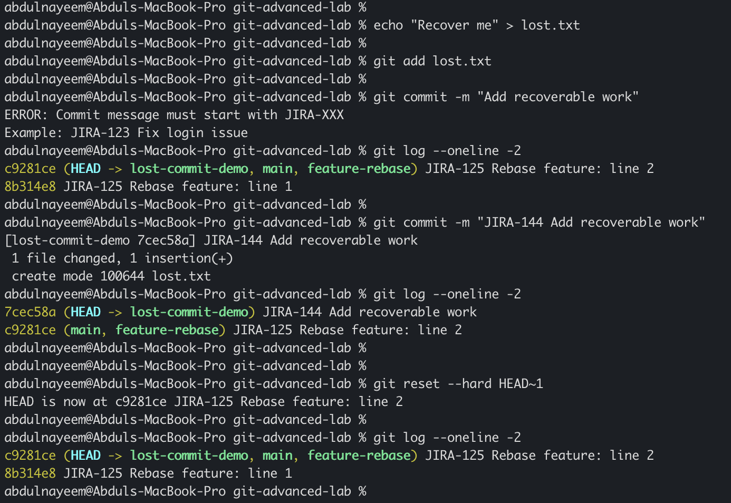

Recover using reflog
git reflog
# Find the commit hash from "commit: Add recoverable work"
git branch recovered-work <LOST-COMMIT-ID>
git switch recovered-work
git log --oneline -3
cat lost.txt
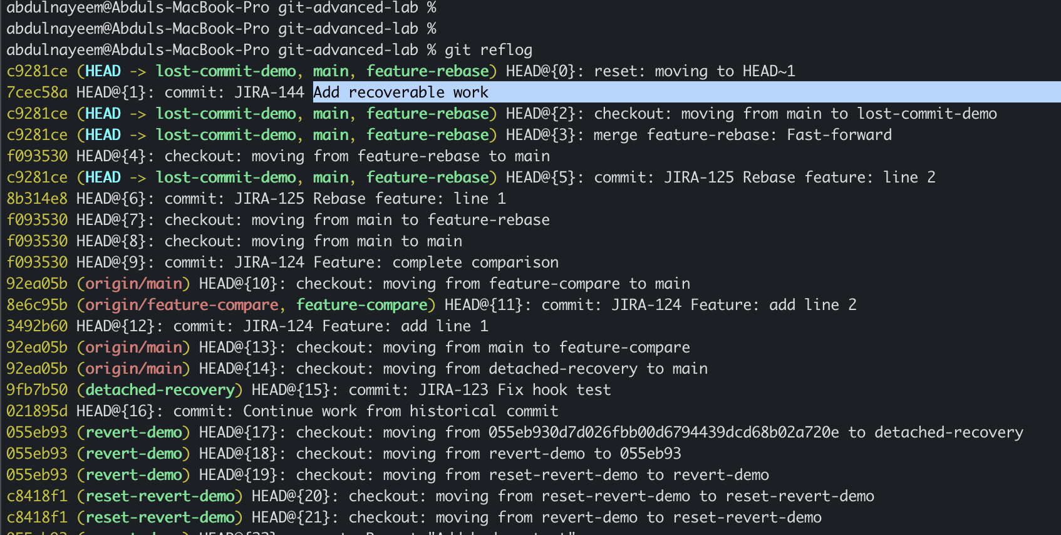
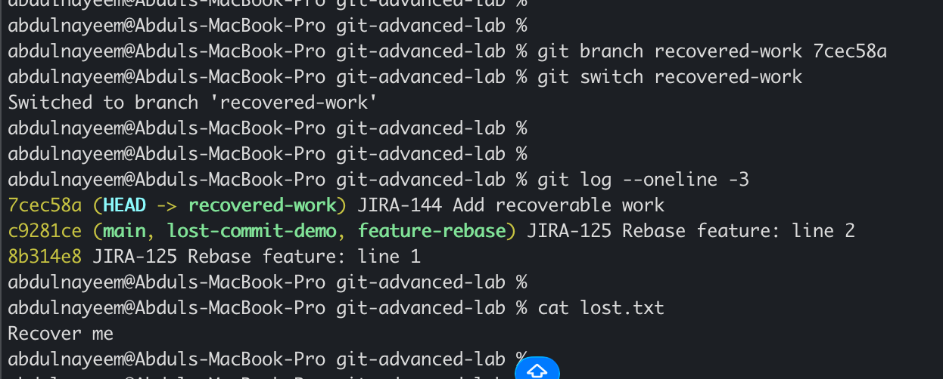
Evidence to capture: Commit before reset | Branch after reset | Reflog showing lost commit | Recovered branch and file

Useful Git Commands for Evidence
git status
git branch -a
git log --oneline --graph --decorate --all
git reflog --all
git remote -v
git show --stat HEAD
git tag
git diff
git diff HEAD~1 HEAD

Expected Learning Outcomes
After completing the assignment, we should be able to diagnose and resolve merge conflicts, recover commits and branches, safely undo shared changes, manipulate local history with amend/rebase/reset, move individual commits with cherry-pick, manage tags, use sparse checkout, understand detached HEAD, enforce commit conventions with hooks, compare merge strategies, and participate in a fork-based pull request workflow.

